BUILDNG A BLOG APP:

Offered by **Smart Internz**



**TEAM ID:** LTVIP2023TMID08038

Team Leader- Rattu Keerthi(20NM1A04E7)

Pondara Prathyusha (20NM1A04E1)

Reddypilly Sai Harshitha (20NM1A04E8)

Tantapureddy Lohitha (20NM1A04G9)

**INTRODUCTION:**

Online shoe store gives you the facility to manage your business remotely. Now, you can vacation on another continent while relishing an influx of customers. You can also keep tabs on your business without stepping out of your house. Online shoe stores give you more freedom regarding marketing and advertising. Now, you can advertise your business more effectively, efficiently, and vigorously with the help of Search Engine Optimization tools.

**PROJECT DESCRIPTION:**

The E-commerce: Shoe Store is a web application that provides the user to watch various shoes.

This code creates a visually appealing webpage for an e-commerce Nike shoe store, featuring a product showcase, contact form, and footer with social media links. It uses Bootstrap for responsive design and styling components, as well as Animate.css for animation effects

**TECHNICAL ARCHITECTURE:**

The architecture of the given HTML code involves layers for user interface, styling, responsiveness, external resources, interactivity, animations, social media integration, accessibility, and deployment. These layers work together to create a visually appealing, responsive, and interactive e-commerce shoe store webpage.

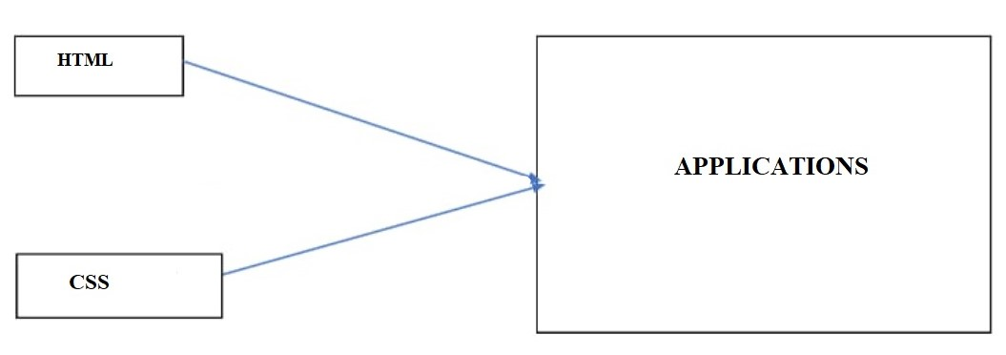  
**PROJECT OBJECTIVE:**

This webpage aims to showcase a variety of Nike shoe products, allow users to explore product details, provide a means for users to connect with the store through a contact form, and offer a seamless browsing experience on different devices through responsive design. Additionally, the inclusion of animations and social media links aims to enhance user engagement and interaction.

**PROJECT FLOW:**

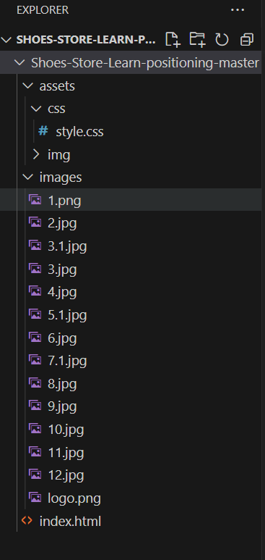

**PROJECT STRUCTURE:**

The structure of E-commerce shoe store involves several components that work together to provide users with real-time information. Below is an outline of the key components and their functionalities:

1. User Interface (UI):

* **Input Field**: Allows users to enter the name of the brand of the shoe to check the popularity for.
* **Search Button**: Triggers the data retrieval process when clicked.
* **Information Section**: Displays the retrieved data.
* **Contact**: Allows user to connect more and can give their queries.

1. HTML File (index.html):

The main HTML file that contains the structure of the web page.

1. CSS (style.css):

The CSS file that defines the styles for the user interface.

Contains the basic structure of the app's user interface.

The below Figures shows the html code used to create the shoe store.

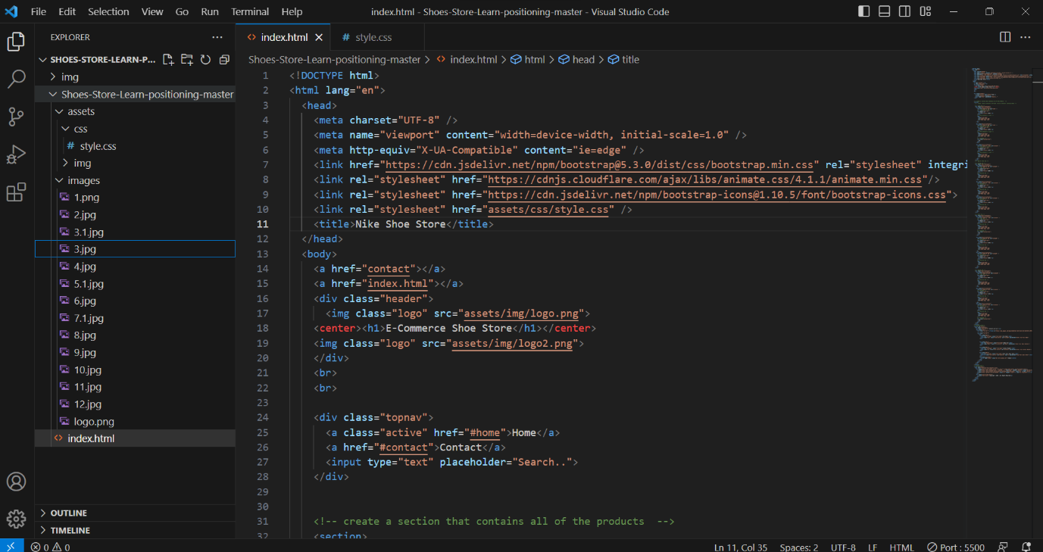

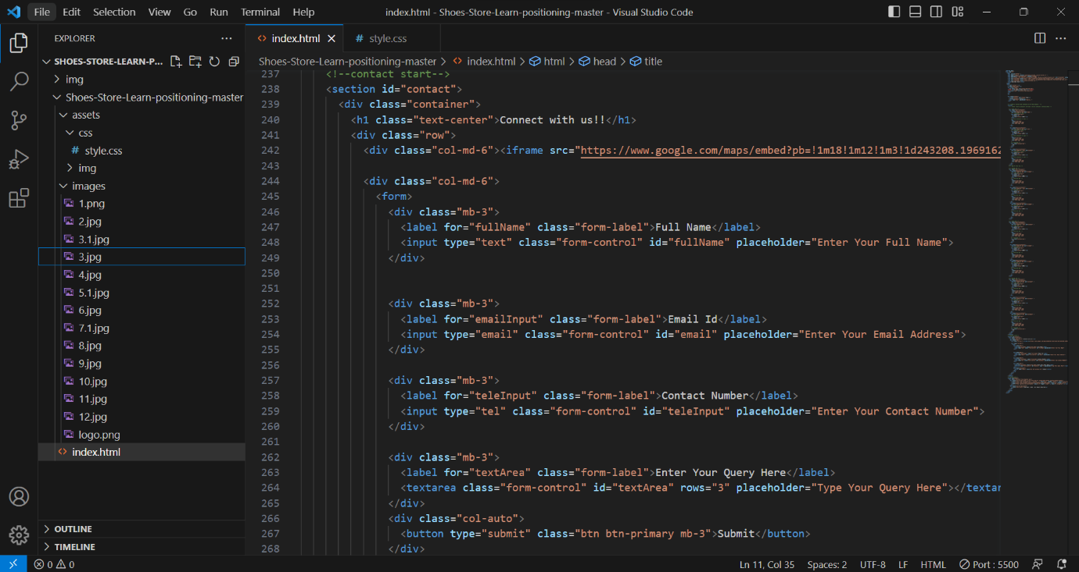

3. CSS File (styles.css):

* Defines the styling and layout of the user interface.
* Formats fonts, colors, backgrounds, buttons, and input fields.

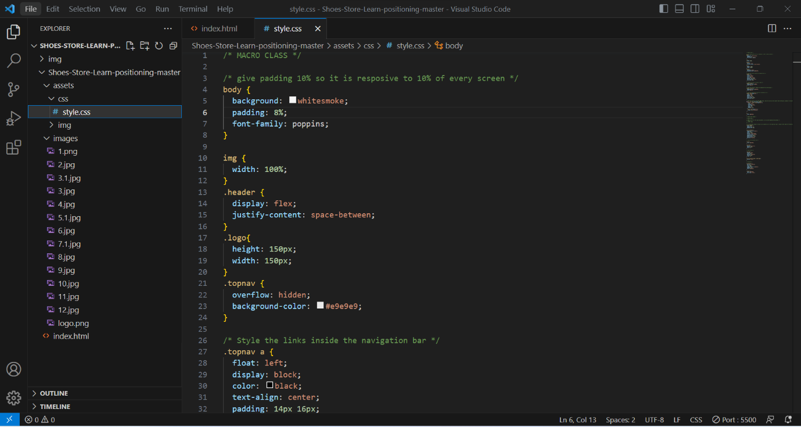

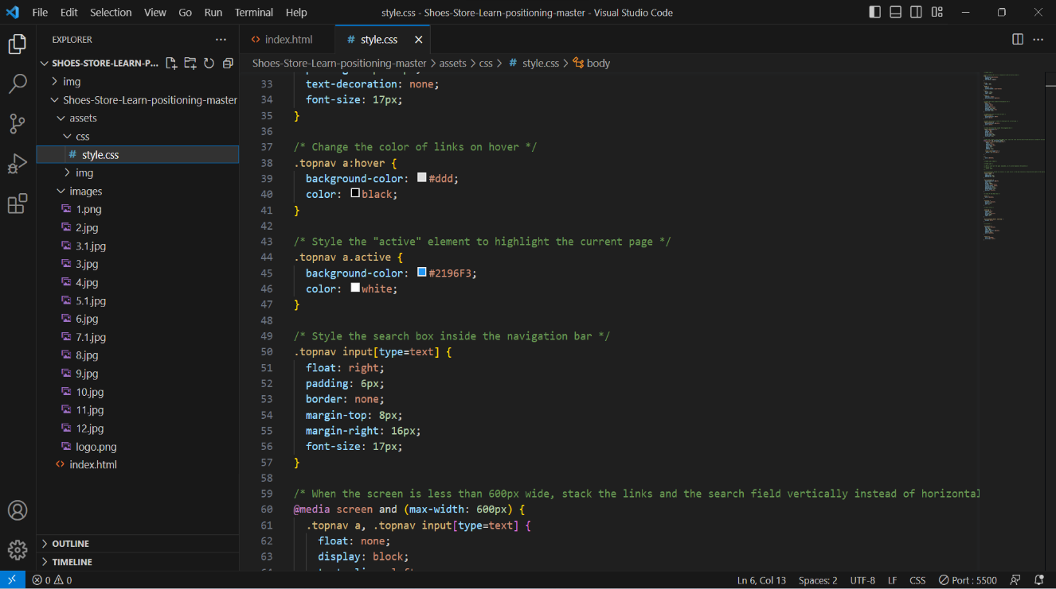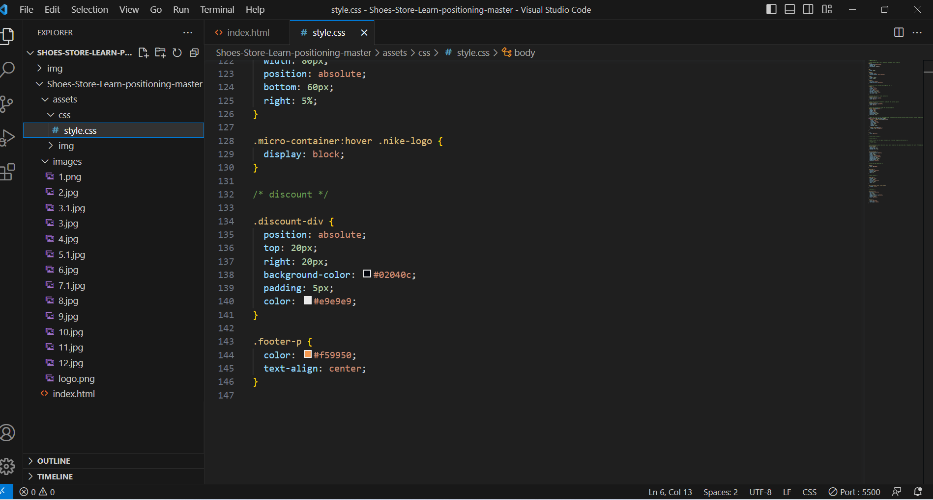

Fig 2. CSS code

**The interaction flow of e-commerce shoe store can be summarized as follows:**

Users land on the homepage ➜ Explore product showcase ➜ Navigate using the menu ➜ Engage with the contact form and Google Maps ➜ Connect with social media links in the footer.

In detail view of the e-commerce shoe store -

User Arrival:

* Users access the webpage through a web browser.
* The logo and store name greet them at the top of the page.

Homepage Exploration:

* Users land on the homepage displaying the logo and store name.
* They can see the navigation bar with "Home" (active), "Contact," and a search input.

Product Showcase:

* As users scroll down, they encounter the product showcase section.
* Rows of shoe products are presented in a visually organized manner.
* Each product item includes an image, brand ("Nike"), and price.
* Some products display a discount label to highlight special offers.

Navigation:

* Users can click on the "Home" link in the navigation bar to scroll back to the top of the page.
* Alternatively, they can click on the "Contact" link to jump directly to the contact section.

Contact Interaction:

* Upon clicking the "Contact" link, users are taken to the contact section.
* Here, they find a Google Maps embed displaying the store's location.
* A contact form is provided for users to input their name, email, contact number, and query.

Submission:

* Users can type their information and queries into the contact form.
* Upon submission, the form data can be processed on the server side (not shown in the provided code).

Footer Interaction:

* At the bottom of the page, in the footer section, users find icons representing social media links.
* These icons lead to the store owner's profiles on Instagram, LinkedIn, and GitHub when clicked.

Responsive Experience:

* Throughout the interaction, the webpage adapts its layout for optimal viewing on various device sizes.

Visual Engagement:

* Animate.css animations are triggered as users scroll, adding subtle but engaging visual effects to certain elements.

The code's design aims to provide an informative, visually appealing, and user-friendly experience for visitors to the e-commerce shoe store webpage.

**PROJECT OUTCOME:**

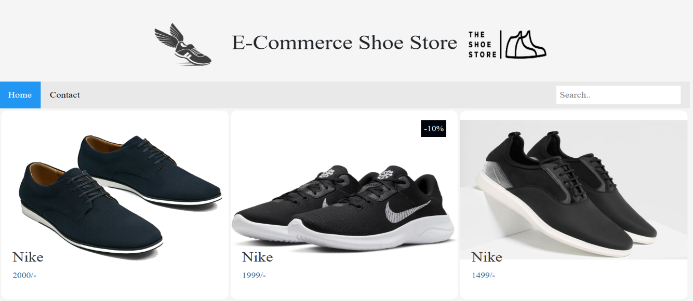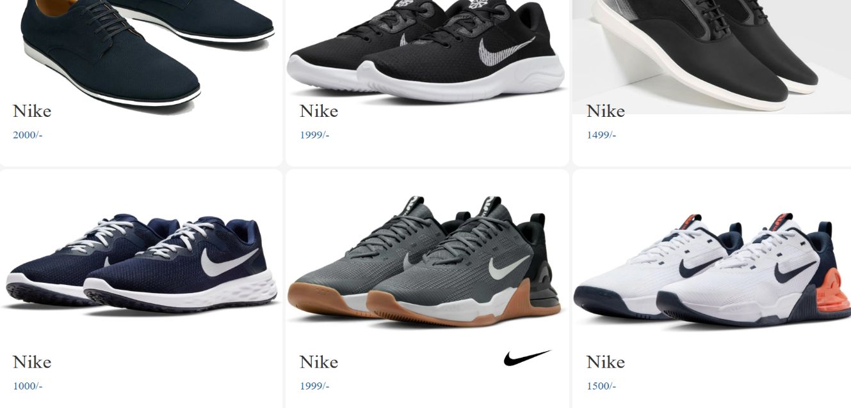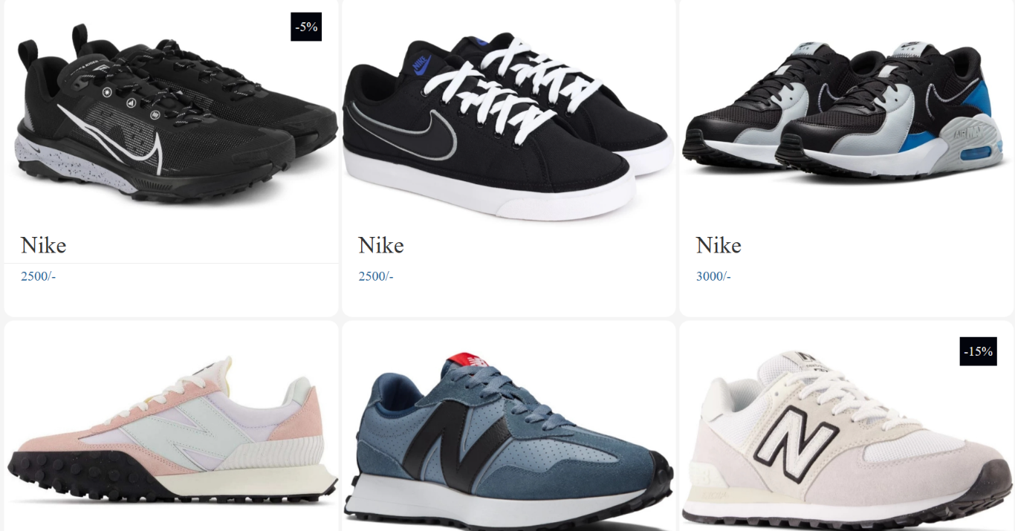

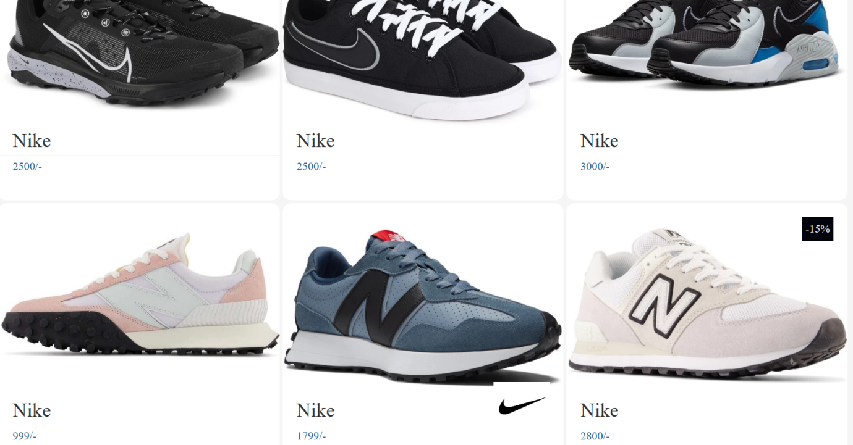

Fig - Various Nike shoes

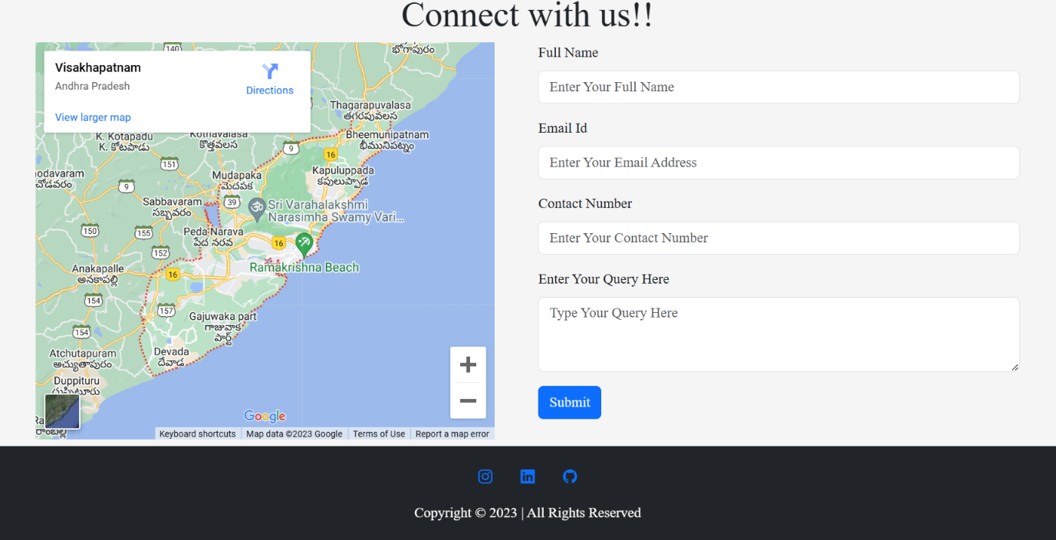

Fig – Footer section

**CONCLUSION:**

The provided HTML code establishes an e-commerce shoe store webpage for showcasing Nike products. Leveraging technologies like HTML, CSS, and Bootstrap, the page offers responsive design, engaging animations, and user-friendly navigation. Through a well-organized layout, contact form, and visual appeal, the code aims to create an immersive shopping experience for users interested in Nike shoes.

**GITHUB LINK:**

https://rattukeerthi.github.io/shoe_store/